Elastos White Paper

BLOCKCHAIN POWERED INTERNET

Elastos Foundation
August 15, 2017

Content Description:
This document is Elastos White Paper v0.1 and describes the project background, objectives, and technical architecture. The document will be continuously upgraded to present the latest Elastos development status.

For details on the latest version of the Elastos white paper, roadmap, team, foundation management, investors, and strategic partners, please visit the Elastos Foundation website.

Contact us:
Elastos Foundation:
Floor 11, Huahong International Building, No. 463 Tanggu Road, Hongkou District, Shanghai, China
Zip code: 200080

Tsinghua-Elastos Joint Blockchain Lab:
Room B-561 of iCenter in Tsinghua University, Haidian District, Beijing, China
Zip code: 100084

Email addresses:
White paper workgroup: whitepaper@elastos.org
Global community: global-community@elastos.org
Elastos Fund: elastos-fund@elastos.org
Public Relations: pr@elastos.org
Investor Relations: ir@elastos.org
Elastos council: elastos-council@elastos.org
Other contacts: contact@elastos.org

Elastos Foundation official website: http://www.elastos.org/

Copyright Notice:
The Elastos Foundation reserves all rights to this document.

Disclaimer:
As technologies rapidly evolve, we will continuously improve and optimize technical solutions to promote Elastos project development. However, regardless of development schedule, ELA token allocation will remain unchanged.

The Elastos Foundation is in the process of being registered. The registration progress complies with all local laws and regulations.

Elastos is the world's first Internet operating system that uses the Internet as the base-layer infrastructure rather than an application. The Elastos approach emphasizes that network communications should be separated from application computing, and prohibits application programs from direct access to the network to eliminate most viruses and attacks (especially DDoS attacks) on the Internet. Elastos is an open source system and has received sponsorship of over 200 million RMB from the Foxconn Group and other industry giants for its R&D. Elastos has open-sourced tens of millions of lines of source code, including more than four million lines of original source code (see http://github.com/elastos/).

Under the leadership of Chen Rong, several hundred people have worked on Elastos development for many years. However, the appropriate market window period (as with DOS and Windows) was not reached until the advent of the blockchain.

Blockchain technology allows user IDs, website IDs and digital asset IDs on a new Internet to be traceable. It can also create digital asset scarcity, laying the foundation for a digital smart economy. Bitcoin started a digital-currency era. With cash on delivery digital transactions, not only does the scarcity need to be identified, but decentralization must also comply with the operation of smart contracts.

After dozens of discussions, Chen Rong, Han Feng, and Xu Jizhe reached a consensus that a safe operating system is necessary for the decentralized automatic smart economy. With the help of Elastos, massive decentralized Apps (DApps) can be safely implemented. With accurate confirmation and contract transfer using blockchains, various works, contracts, ideas, and intellectual properties in digital form become assets in the digital world.

Elastos creates a brand new smart economic zone on the traditional Internet. Elastos coins (ELA) become the digital currencies in this economic zone.

Elastos is a blockchain-powered Internet, making it possible for digits to become wealth and bringing the Internet economy to new levels of utility.

Table of contents
0. Background 5
1. Smart Economy Outlook 6
2. Elastos: Blockchain Powered Internet 6
2.1 Credit System 7
2.2 Security 8
2.3 Rights Confirmation, Transaction, and Circulation of Digital Assets 9
2.4 Decentralized Applications (DApps) 9
3. Elastos Blockchain 10
3.1 Transaction and Block Design 10
3.2 Merged Bitcoin Mining 11
3.3 ELA Tokens and Their Allocation Solution 11
3.4 Auxiliary Blockchain 14
3.5 Smart Contract 15
3.6 Network Interconnection 16
4. Elastos Carrier: Infrastructure for a Decentralized Internet 16
5. Elastos OS: A Secure, General Purpose Operating System 16
6. Elastos Runtime: Runtime Environment for DApps 19
6.1 P2P Internet Communication 19
6.2 Digital Asset Operations 20
7. Elastos Foundation 22
7.1 Global Community 22
7.2 Cultivation of Specialists 23
7.3 Construction of an Ecosystem 23

- Background

Following thousands of years of development, human beings have created a glorious civilization in the material world and accumulated huge fortunes. With the innovation of the computer and Internet, human beings have entered an information era, creating the world composed of virtual bits which flow at the speed of light. Information has exploded. The scarcity of data has been replaced by Big Data. Entire worlds of data have been created from scratch. These worlds influence the physical world during automated transactions and asset exchanges. The digital fortunes of humanity will grow and become more prosperous, leading to the rapid ascent of human civilization.

The history of the digital world is astonishing. Important persons and events recorded include Satoshi Nakamoto and Bitcoin. On October 31, 2008, Satoshi Nakamoto released his thesis Bitcoin: A Peer-to-Peer Electronic Cash System by email. The next year, he released Bitcoin software in free open-source software format, creating the Bitcoin network and starting the digital currency era. He had developed a decentralized and automatic credit production system. Even more legendary is that the real identity of Satoshi Nakamoto is still a mystery. Bitcoins and related technologies were first adopted by a small number of technical partisans geeks and are now entering the mass market and gradually being integrated into various industries from the earliest technical experiments. There is no doubt that bitcoins and blockchains are changing the world. However, looking to the future, the current digital currency and blockchain technologies are still very young and need to be optimized as more and more talented people from around the world are committed to this field.

In contrast to the hype, there are very few real applications which fully utilize blockchain technology and digital currency.

This is because the current blockchain technology is mainly used at the base layer of decentralized computer architecture. Users do not ask for a technology. Instead, they want an application to solve problems to better their lives. In other words, there is a huge gap between the blockchain technology and a rich user experience, which is a problem that needs to be urgently settled. This is where the Elastos Project must come in, to fill the gap between blockchain technology and the masses.

Elastos uses the Internet and blockchains as base-layer infrastructure, providing support for the development of decentralized applications (DApps), offering a reliable and secure running environment for the digital world, promoting digital rights, transactions and the circulation of digital assets. In this case, digital information becomes more valuable and the Internet economy is upgraded to new heights.

- Smart Economy Outlook

Starting from the first digital computer, our computing capability has increased exponentially and has permeated all aspects of economy and society. Thanks in part to the Moore's Law, most people find themselves part of the digital world. In centralized and cloud computing controlled scenarios, we live a life immersed in semi-automatic economy, with examples in e-commerce, bike-sharing and robotics. The operating efficiency of our whole society has improved dramatically.

So why hasn’t the fully automated economy arrived yet? One important reason is owing to the insecurity of the Internet due to viruses, weak privacy, tampering, and hacking. In other words, it is dangerous for computers to process information if that information in transmission is unreliable and devoid of a credible source. In addition, an automatic economy must not depend on centralized control. It must be decentralized to ensure that individuals and commercial institutions around the world can participate equally.

Smart economies require exponentially increasing computing capabilities to serve the basic protocols for market operations. For example, if digital currency exchanges could operate in a automatic and decentralized fashion, it would greatly improve efficiency and fairness to all parties.
A single computer that meets specific technical specifications may join a blockchain network without being approved by anyone, becoming a node of the blockchain network, validating and backing up its distributed ledgers. In this case, this computer, together with other node computers, form a blockchain computer. The blockchain computer is abstract, not controlled by a few nodes, cannot be broken down and is redundant. In addition, blockchain technology creates digital asset scarcity, laying the foundation for the smart economy.

- Elastos: Blockchain Powered Internet

To facilitate a smart economy, the third phase of Elastos project was conceived.

The Elastos project can be traced to the year 2000 when Chen Rong returned to China to start his business. From that time, Chen Rong has been committed to developing an operating system that is secure and adaptive in the network era. He has received sponsorship for Elastos from technology giants in the industry covering R&D and accumulating rich technologies. The first attempt of Elastos was to develop a smartphone from scratch in 2003, the highlight of which was to design a TD-SCDMA smartphone OS for the WoPhone of China Unicom. The second endeavor of Elastos started in late 2012 and ended in 2016, founded by Foxconn Group, to develop an OS for the Industrial IoT and smart home devices. Starting in 2017, the Elastos project has been transformed to a community-driven, free, open-source software project, which is the current and third campaign of Elastos.

Elastos is the technical infrastructure of a smart economy. The overall technical architecture includes a public blockchain, a decentralized Internet infrastructure, and a runtime environment for conventional apps, mobile apps and decentralized apps (DApps). Elastos provides a credit system, a secure computing environment, rights confirmation, transactions, registration and circulation of digital assets in a smart economy. In addition, Elastos provides software development kits (SDKs) to help developers building apps and DApps of practical use.
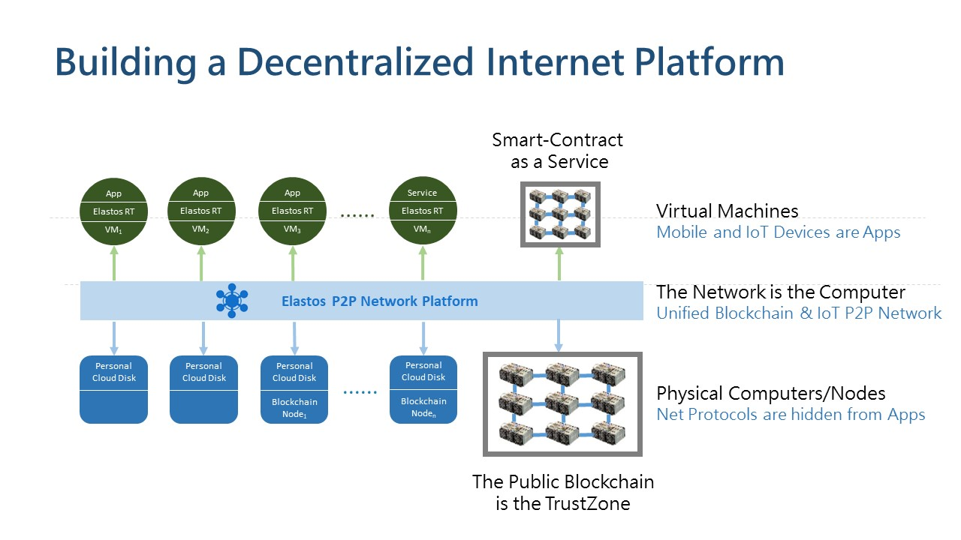
Overall Elastos Architecture

2.1 Credit System

Since the 1970s, US dollars have been unpegged from gold and the Bretton Woods global credit system has broken down. Global credit production depends fully on human credit. Now, the Bitcoin mining industry is evolving into the future global credit production infrastructure and strategic resource. This indicates that the credit system of human society unpegged from natural resources is changing slightly and human credit resources are starting to turn back to natural resources (computing capability) again.

Elastos founding members released People Who Produce Global Credit in March 2016. The report pointed out, for the first time, that China had already occupied more than 50% computing capabilities in the global Bitcoin mining industry. Around the same time, Elastos formed a blockchain mining credit production alliance with strategic partners, such as Bitmain, BTC.TOP, BTCC and Bixin to upgrade Bitcoin computing capabilities into credit production as public services while reducing energy consumption and carbon emissions.

Elastos Blockchain cooperates with its strategic partners for merged Bitcoin mining, which means that the Elastos Blockchain would gain a strong computing capability guarantee since day one of its operation. Elastos is dedicated to provide an international public blockchain of a basic credit production service for global innovation, especially within the Elastos ecosystem.

2.2 Security

Traditional Operating Systems (OS), such as UNIX, were created before the Internet became a mainstay. Therefore, most OS’s today are standalone OS’s for single hardware machines. The Internet infrastructure protocols, such as TCP/IP, are merely an application-level service. One of the consequences has been that third-party applications and services are prone to viruses, privacy leaks and network attacks.

Elastos is an end-to-end solution which implements the concept of a network-oriented OS, one where applications and services execute across the Internet. Applications and services are not allowed to directly access network sockets for Internet access, and must instead, submit destination universal unique IDs to Elastos system API, which in turn find its destination and relay all messages in a controlled fashion. In such a system architecture, each application and service is securely isolated, cannot directly access network interfaces and can only use unified and permissioned policies to access local and Internet resources.

In Elastos, applications can no longer disclose confidential information through the Internet or use Internet of Things (IoT) zombie devices to implement network attacks, e.g., DDoS attacks. In addition, applications cannot connect to the backend or remote services without permission, nor could they inject malicious viruses. Furthermore, the Elastos OS uses the Elastos blockchain as the trust-zone, which ensures security and reliability of programs and data sources on the Internet. Blockchain is not only a trustable Internet of digital currencies but also the trustable Internet of applications, services and digital assets.

2.3 Rights Confirmation, Transaction, and Circulation of Digital Assets

In the digital world, resources are copied and transmitted at almost no cost. However, it is extremely difficult to create fortunes from digital resources, because even though they are massively produced, circulated, consumed, and certainly do create value, the digital rights to resources cannot be confirmed. Additionally, with widespread piracy and counterfeiting, the original value of a digital asset is diminished and since digital information is so difficult to convert into money, the development of the virtual economy encounters a bottleneck.

Blockchain technology has proved that digital currencies are feasible. Yet, while we can create scarcity of digital assets and pay for them with digital currency, we have often overlooked the fact that digital contents must be executed to present its value. Could we trust all applications to abide by the rules dictated with smart contracts? Or should we trust a single open source OS runtime to abide by the rules?

Elastos provides infrastructure for rights confirmation, transaction and circulation of digital assets. After digital resources are released to the network using the blockchain technology, the digital resource rights are confirmed and the digital resources become trustable digital assets on blockchains to be circulated and exchanged. To release the digital assets, you must have an Elastos wallet and an account balance sufficient to pay for the miner fees. At that point, you can submit a rights confirmation transaction request.

The request must include certain information, such as the owner's wallet address, resource URL, quantity, and unit price. The resource hash value is calculated and a record of the transaction as an Unspent Transaction Output (UTXO) is created on the blockchain. After the rights confirmation transaction record is released on the blockchain, the resources themselves become exchangeable digital assets. After the purchase transaction takes effect, the digital asset ownership is transferred to the account of the customer who purchases it. Except the usage value, the digital asset can be sold repeatedly.

2.4 Decentralized Applications (DApps)

Based on current blockchain technologies, there is no DApp competing with existing mainstream applications.

Although a blockchain computer is Turing complete, it does not mean that blockchain computer could run real world applications. In comparison the graphics card, the sound card, the network card, the hard drives, and the video cameras, they all have CPUs in them, so they all are Turing complete, but do we use them to execute consumer applications? The answer is NO. But why then in the world, a public blockchain should/could run real consumer applications? The redundant nature of a blockchain computer which has thousands of repetitive nodes follows the Amdahl’s law instead of the Moore’s law.

Elastos has a build-in public blockchain, hidden from all users and applications, that issues ELA tokens and provides ID registrations. All smart contracts and DApps are executed on auxiliary blockchains, which are application level functionalities on top of Elastos network OS.

- Elastos Blockchain

In the same vein as a mobile phone’s trust-zone, which is necessary for the storage of security-related data such as fingerprints, the Elastos Blockchain serves as the trust-zone of the Elastos Ecosystem, providing basic credit and transaction services throughout.

To meet the requirements of the realization of the smart economy and the development of DApps, each Elastos application will have the power of independently establishing Auxiliary Blockchains. The Elastos SDK will facilitate the emergence of such Auxiliary Blockchains as are embedded, complete, and easy-to-use. An Auxiliary Blockchain will have multiple consensus algorithms for the issuance of tokens which the user may choose from. Both the Parent Blockchain and the Auxiliary Blockchains will support bidirectional asset transfers. The Auxiliary Blockchains will share their ledgering capabilities with the Parent Blockchain, thereby guaranteeing that the Auxiliary Blockchains will have the same level of security as the Parent Blockchain. In addition, the energy consumption of the entire system may be minimized to prevent waste and unnecessary carbon emissions caused by separate mining strategies.

3.1 Transaction and Block Design

The design of the Elastos Blockchain is based upon existing digital currency systems, including the "previous" block header hash required for block verification, the Merkle root hash, the counter (or nonce) required for the proof-of-work (POW) algorithm, the "timestamp" field, and the "difficulty" field. The chain-based structure will enable transactions to obtain the accumulated protection of POW and will achieve decentralized consensus to facilitate automatic credit protection.

Based on existing experiences concerning digital currency systems and blockchains, Elastos adopts the concept of distinct "parent" and "auxiliary" chains, and removes unnecessary verification scripts from the transaction structure, which will reduce transaction space and prevents extensional attacks. The Auxiliary Blockchains will be a necessary basis for the execution of many DApps. Therefore, the Parent Blockchain will need to provide support to the Auxiliary Blockchains, such as to ensure smooth, convenient, and efficient asset transfer.

3.2 Merged Bitcoin Mining

The Elastos Blockchain will adopt a merged Bitcoin mining mechanism. Bitcoin will be used as the Parent Blockchain and ELA tokens will be used within the Auxiliary Blockchains. By deploying merged mining codes to the mining pool, miners can submit the POW to receive Bitcoin and ELA rewards at the same time without the consumption of extra computational cycles, which will result in higher income for miners.

By means of merged mining, the Elastos Blockchain will command strong computing capabilities and will provide basic credit production services for global blockchain innovation, especially within the Elastos Ecosystem.

3.3 ELA Tokens and Their Allocation Solution

ELA tokens (ELAs for short) are original tokens under Elastos used to exchange digital assets upon auxiliary blockchains, and to pay blockchain transaction fees. To honor and commemorate the digital currency initiator Nakamoto Satoshi, Elastos uses the Satoshi ELA (Sela for short) as the minimum ELA unit. In addition to Sela, other currency units are provided. The following chart describes conversion relationships.
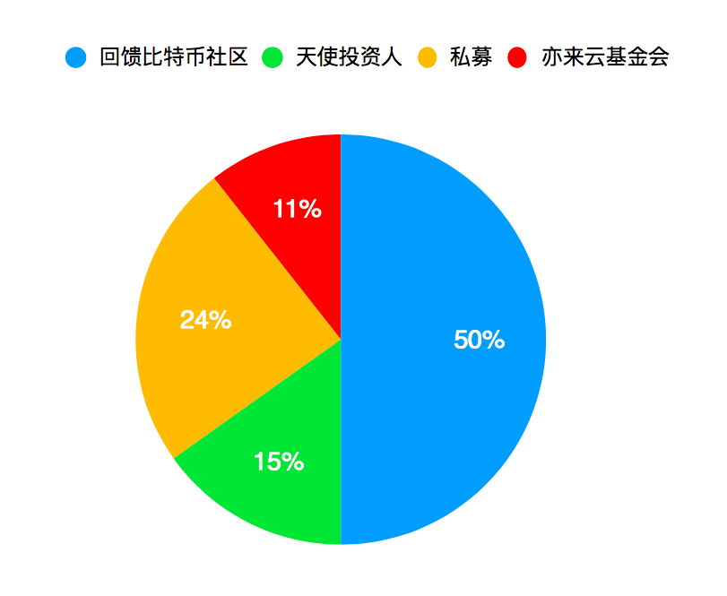

For the purpose of promoting the Elastos Ecosystem’s operation, and with reference being made to the total circulation of US dollars (around 2,000 trillion) and total Bitcoin circulation (2,100 trillion Satoshi), it has been decided that 3,300 trillion Sela, that is, 33 million ELAs will be created as a one-time event within the genesis block of the Elastos Blockchain independently of mining.

The following table describes the allocation solution and implementation rules of ELAs.

To make up for the naturally lost money supply due to wallet loss, and to retain the element of inflation for the continued support of the economy, the ELA supply increases by 4% every year. Increased ELAs will be released by means of new blocks, being generated every two minutes during merged mining. To ensure sustainable development of the Elastos system, ELAs will be allocated between the Elastos Foundation and miners for two years based on a specific ratio. The Elastos Foundation will own 30% of the ELAs and the miners will own 70%.

ELA  (Unit: Ten Thousands) | Function | Description
1650 | Feedback bitcoin community | Bitcoin owners are determined based on the time when the Genesis block of the Elastos blockchain is generated and free ELAs are issued to them. The detailed rules are as follows:  - Purpose: Repay the digital currency community and ensure effective circulation.  - Quantity: Bitcoin owners obtain the same quantity of ELAs.  - Channel: ELAs are issued only by digital currency exchanges.  - Method: Bitcoin owners need to apply for ELAs proactively through the preceding channel. ELAs will not be automatically sent to bitcoin owners.  - Validity period: Bitcoin owners can apply for ELAs within one year started from the Genesis block generation time. If a bitcoin owner does not apply for the ELAs within the specified time, it regards that he or she voluntarily gives up and cannot apply for these ELAs again. All ELAs that are not applied for will be used as the Elastos capital for Elastos ecosystem establishment. These ELAs will not be used for routine operation of the Elastos foundation.  - Release rule: To ensure reasonable circulation and community stability, all ELAs applied for will be released in four years. In the first, second, third, and fourth years, 10%, 20%, 30%, and 40% ELAs are released respectively.
500 | Angel investors | The Elastos team and other related resource providers form the Elastos project angel investors. They are the core force of Elastos and will long-term support and promote Elastos development.
800 | Private-equity | All digital currencies obtained through private-equity are owned by the Elastos foundation for Elastos ecological platform development and previous trial operation.
350 | Elastos Foundation | The Elastos foundation will reserve funds to:  - Support Elastos foundation operation.  - Invest Elastos ecological projects to establish the Elastos ecosystem.

3.4 Auxiliary Blockchain

Users can use related tools to conveniently create auxiliary blockchains and obtain the auxiliary blockchain IDs. Auxiliary blockchain applications need to use auxiliary blockchain IDs to initialize the Elastos runtime, indicating the relationship between DApps and auxiliary blockchains and generating the parent and auxiliary blockchain joint signature address. After a consensus is reached for blocks generated on the auxiliary blockchains, the joint signature address of the created auxiliary blockchain uses the block hash head and block height as content to create a transaction and stores it to the parent blockchain to further ensure the auxiliary blockchain security through the parent blockchain.

Account transfer from the parent blockchain to an auxiliary blockchain indicates that the parent blockchain asset is changed to an auxiliary blockchain asset. The account transfer destination address is the joint signature address of the corresponding auxiliary blockchain on the parent blockchain. During the account transfer process, the account transfer transaction must be automatically identified by the auxiliary blockchain and the auxiliary blockchain ELAs of the corresponding values need to be recharged to the account of the transfer person on the auxiliary blockchain side. In addition, the auxiliary blockchain must be able to identify that the account transfer transaction of the parent blockchain has enough POW. Elastos uses SPV POW to unlock auxiliary blockchain transactions. For non-POW consensuses, the corresponding verification modes are used. The account transfer operation creates two transactions at the same time. One is account transfer from the parent blockchain to the joint signature address of the auxiliary blockchain, and the other is an ELA issuing transaction on the auxiliary blockchain. An ELA issuing transaction is a special transaction without input and the verification rules are different from those of common transactions. The ELA issuing transaction on the auxiliary blockchain can be unlocked using the SPV POW of the account transfer transaction on the parent blockchain.

Account transfer from an auxiliary blockchain to the parent blockchain indicates that ELAs are transferred from the joint signature address of the corresponding auxiliary blockchain on the parent blockchain to the account of the user on the parent blockchain. The user triggers an account transfer request on the auxiliary blockchain side to create a transaction from his or her own auxiliary blockchain account to the parent blockchain address and provides a random number to identify the transaction from the joint signature address on the parent blockchain to his or her private address.

The transaction takes effect if the user receives the account transfer transaction including the random number provided in the auxiliary blockchain transaction from the joint signature address in the corresponding address on the parent blockchain and if the account transfer quantity is the same according to the SPV POW on the parent blockchain.

After the auxiliary blockchain transaction is sent out, the node in the joint signature address needs to manually or automatically create and sign the account transfer transaction from the parent blockchain address to the user private address to ensure that the transaction on the auxiliary blockchain side can be unlocked.

To ensure security of ELAs in the joint signature address, only drawing transactions can be initiated from the joint signature address. In addition, the corresponding account transfer transaction on the auxiliary blockchain needs to be verified.

3.5 Smart Contract

If strong smart contract function is provided on the parent blockchain, each node needs to run all smart contracts not operated to obtain the latest network status. However, only miners packaging transactions can obtain the transaction fees. Therefore, for nodes that run smart contracts only for verification, computing resources are wasted. If contracts are frequently invoked or the invoked number of contracts is huge, they will bring excessive pressure for contract execution, or they might not be successfully executed at all.

To prevent these problems, Elastos parent blockchain supports smart contracts for digital currency transaction in limited places. Auxiliary blockchains can support smart contracts, and each auxiliary blockchain can design independent smart contract functions, for example, NeoContract in the NEO blockchain.

3.6 Network Interconnection

Multiple network nodes do not have fixed IP addresses. As a result, they cannot receive requests from other network nodes. To solve this problem, the NAT traversal technology is used, which allows a network node without a fixed IP address to be proactively connected. The Elastos Blockchain P2P network uses UDP-based NAT traversal technology. In this case, nodes can be proactively connected to by outsiders, and therefore become members of the decentralized P2P network, which greatly expands the Elastos Blockchain’s capacity.

- Elastos Carrier: Infrastructure for a Decentralized Internet

Elastos Carrier is the decentralized internet service provided by the ecosystem of Elastos. Its nodes may be executed within any internet-connected environment, including local area networks within a home or workplace. By using UDP-based NAT transparency techniques, all pairs of nodes will have the power of establishing connections with one another, even direct connections. This will allow for the plenteous utilization of every node's individual capacities, which will serve to increase the effective horse power of the network as a whole.

The set of foundational services will include decentralized domain names, decentralized computation, and decentralized storage. There will be foundational support provided for the development of decentralized applications (DApps). Within such an environment, the user may possess his or her own data and computation under an abundant level of privacy protection. At the same time, the user will have the power of renting out his or her own equipment at will, by means of the Elastos Blockchain, and can collect remuneration according to the amount of computation and storage which was consumed.

- Elastos OS: A Secure, General Purpose Operating System

Elastos OS is a general-purpose operating system based around the respect of security. It is an operating system made to address the needs of the Internet of Things (IoT), of invention kits such as the Raspberry Pi, and of mobile devices. The latest version, namely the third, has been undergoing a process of commoditization since 2013 May, and has successfully achieved beta quality, having been executed and scrutinized upon the Moto X (XT1085) phone and the Lamobo-R1S smart router. The total amount of code involved has exceeded 10 million lines.

With respect to security, Elastos OS prohibits direct process creation and does not allow direct interaction with TCP/IP, depending instead upon the system to automatically spawn and determine the location of local, proximate, and distant (or cloud-based) micro-services. The system will automatically generate remote invocations and provide for event-based responses, thereby evading possible malicious actions on the part of either the application or the remote service, and recusing
itself from relaying viruses further on.

The system will utilize C/C++, Java, and HTML5/JS as the three modes of development. Its C++ API will largely mirror Android's Java API, which will allow for the unified three-in-one management of cloud access, monitoring, and interfacing. Components written in Java, HTML5/JS, and C/C++ will be able to call upon each other in a modular fashion, with no need to manually deal with the JNI. As such, our system truly conforms to the maxim of "write once, run everywhere." The system will support the Component Assembly Runtime (CAR) architecture, as demonstrated by the example below, which uses a CAR component to establish communication between a program written in C/C++ and one in HTML5/JS.

Elastos is different from an Android-like OS in at least four aspects:

1. Elastos has a complete set of novel C/C++ APIs and frameworks, which correspond to the Java APIs and frameworks of Android. With better performance and a smaller footprint, Elastos is a better fit for embedded systems and machines with wireless peripherals. Elastos also supports almost all Android Java and JS APIs and frameworks. POSIX APIs are deprecated.

2. Elastos has a distributed OS runtime to guarantee end-to-end security and integrity across the Internet. With built-in metadata-driven reflection technology, Elastos can automatically generate code to bridge programming modules across languages and machine boundaries. In other words, applications, services and IoT devices are prohibited from sending/receiving network packets directly, in order to fence off network attacks initiated from third party software and hardware.

3. Elastos runtime has a pioneering, service-oriented architecture, designed ideally for containers/virtual-machines. An Elastos runtime can be thought of as a CppVM (vs. JavaVM) without a leaking bottom, i.e., there are no Java-Native-Interface (JNI) equivalent mechanisms to expose the underlying physical machine or host OS. This prevents the possibility of malicious code penetrating into the system layer.

4. Elastos is decentralized across the Internet, and utilizes blockchains to authenticate user IDs, application IDs, as well as machine IDs. To build a flourishing ecosystem, anybody may freely implement their own markets, social apps, search engines, location-based services, advertisement agents, and so on, while being rewarded with Elastos coins.

Elastos OS provides a new and improved decentralized support system for applications being developed, making it easy to interface with Elastos Carrier for the obtainment of the foundational services, and to interface with Elastos Chain to obtain services related to credit and exchange. The resulting DApps may blithely and simultaneously handle Elastos transactions and other types of digital assets, including: source code, data, e-books, video, and gaming items. They might be handling copyrights, transactions, and circulation, among other things.
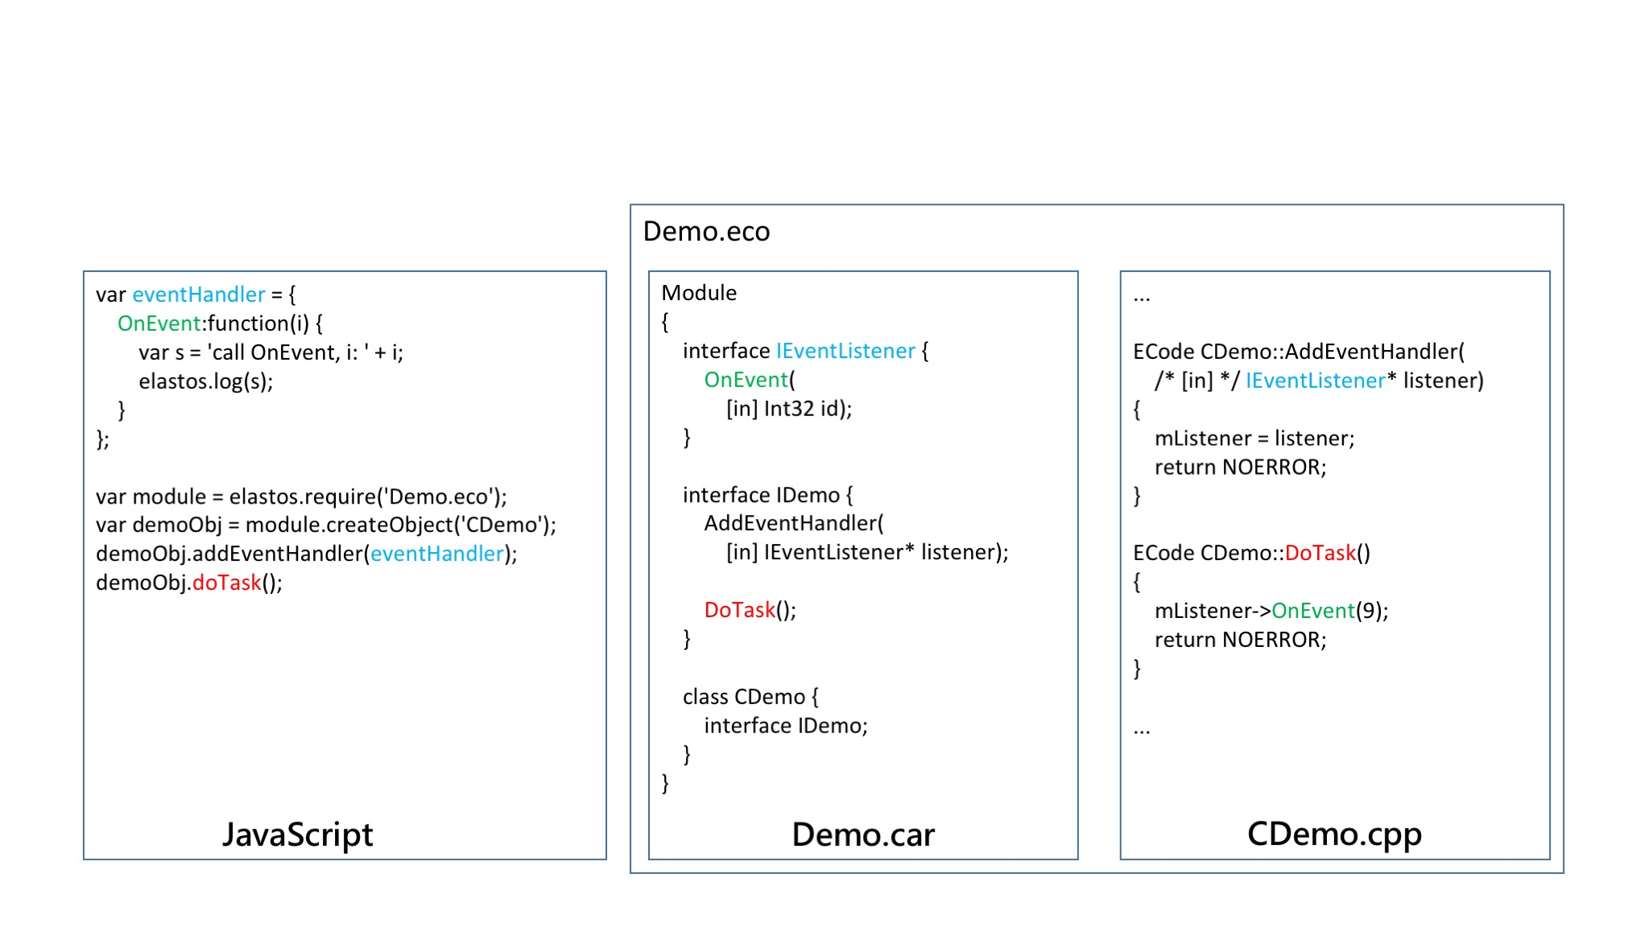
The C++ framework of Elastos OS makes use of Android's application interfaces, which leads to convenience for the developer as well as portability. Elastos OS will even go so far as to execute Android programs directly, thereby achieving the state of affairs as depicted below:
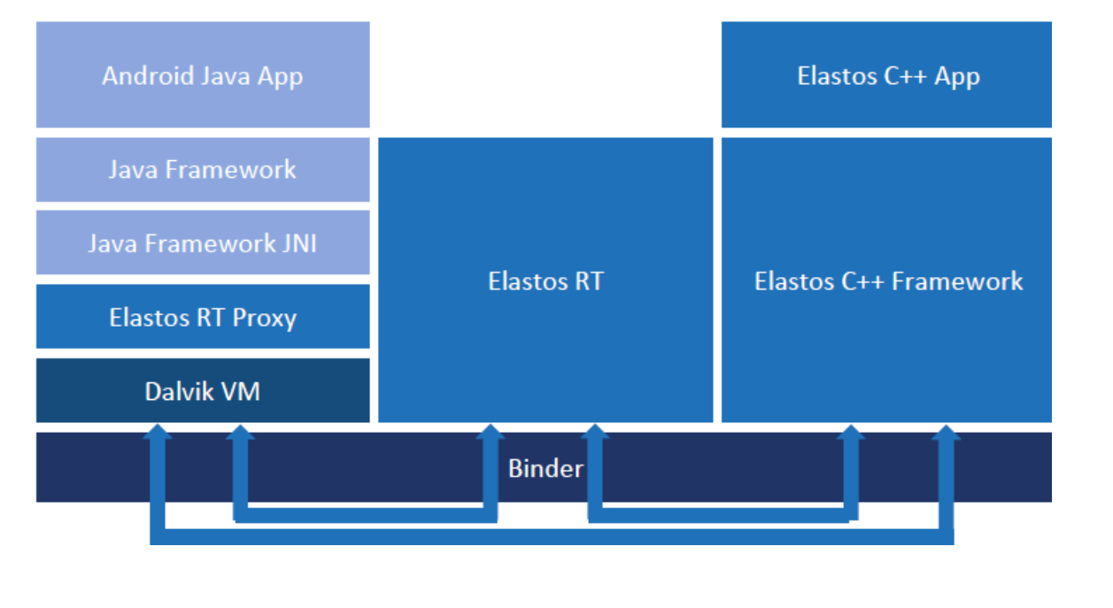

One may think of the Elastos Runtime as the C++ version of the Java Virtual Machine as well as Java's framework. It might even be referred to as the C Virtual Machine (CVM). Elastos OS services and applications will be executed within this CVM, allowing the same services to exist in
harmony with a variegated landscape of nodes and hardware platforms.

- Elastos Runtime: Runtime Environment for DApps

Although the Elastos OS can be obtained at any time in order to enjoy complete and primary support for the development of decentralized applications, there are other numerous occasions where the user would prefer to utilize another operating system which is already at hand. In such cases, he can make use of the Elastos Runtime, a runtime environment which likewise offers complete support for the applications in question. Developers will be able to choose between the Elastos Runtime for Android, Elastos Runtime for iOS, and Elastos Runtime for Ubuntu Linux. Some of the patterns of Elastos development are shown below:

6.1 P2P Internet Communication

Decentralized applications must communicate with each other by means of component interfaces, as they have no means of directly connecting to the internet. This approach is easier, safer, and more natural:
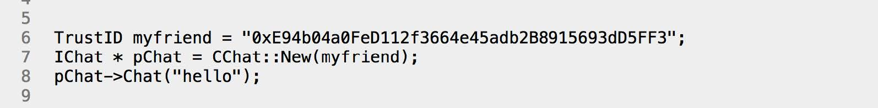

The code above does not need to consider serialization/deserialization or encryption/decryption, nor does the programmer need to be involved in writing new protocols. All of these things can be satisfied the Elastos Runtime’s CAR interface. All which one must do is to edit the CAR document below, and then draft the corresponding functions. Compared with the customary socket-based API, the Elastos Runtime is far easier to use. Moreover, one may perform digital asset transaction as seen below:

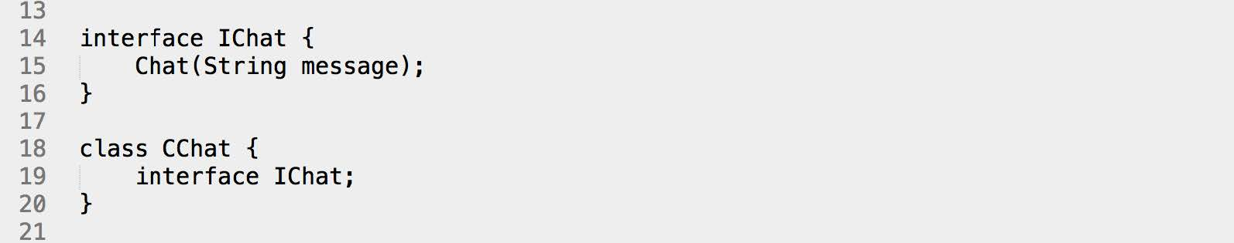

The following code demonstrates how to transact:

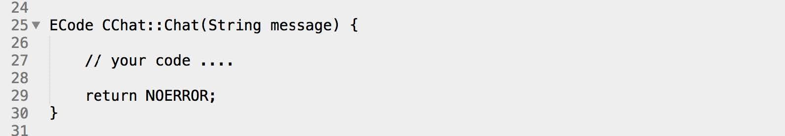

Applications written using the Elastos Runtime are simpler than P2P network applications written using the customary socket API.

6.2 Digital Asset Operations

As shown in the preceding examples, we no longer use IP addresses or domain names for network communication because the current Internet is not trustworthy. However, the Elastos Runtime will perform runtime verification a confirmation during Elastos Runtime development by means of the trust-zone, which is to say, the Elastos Blockchain.

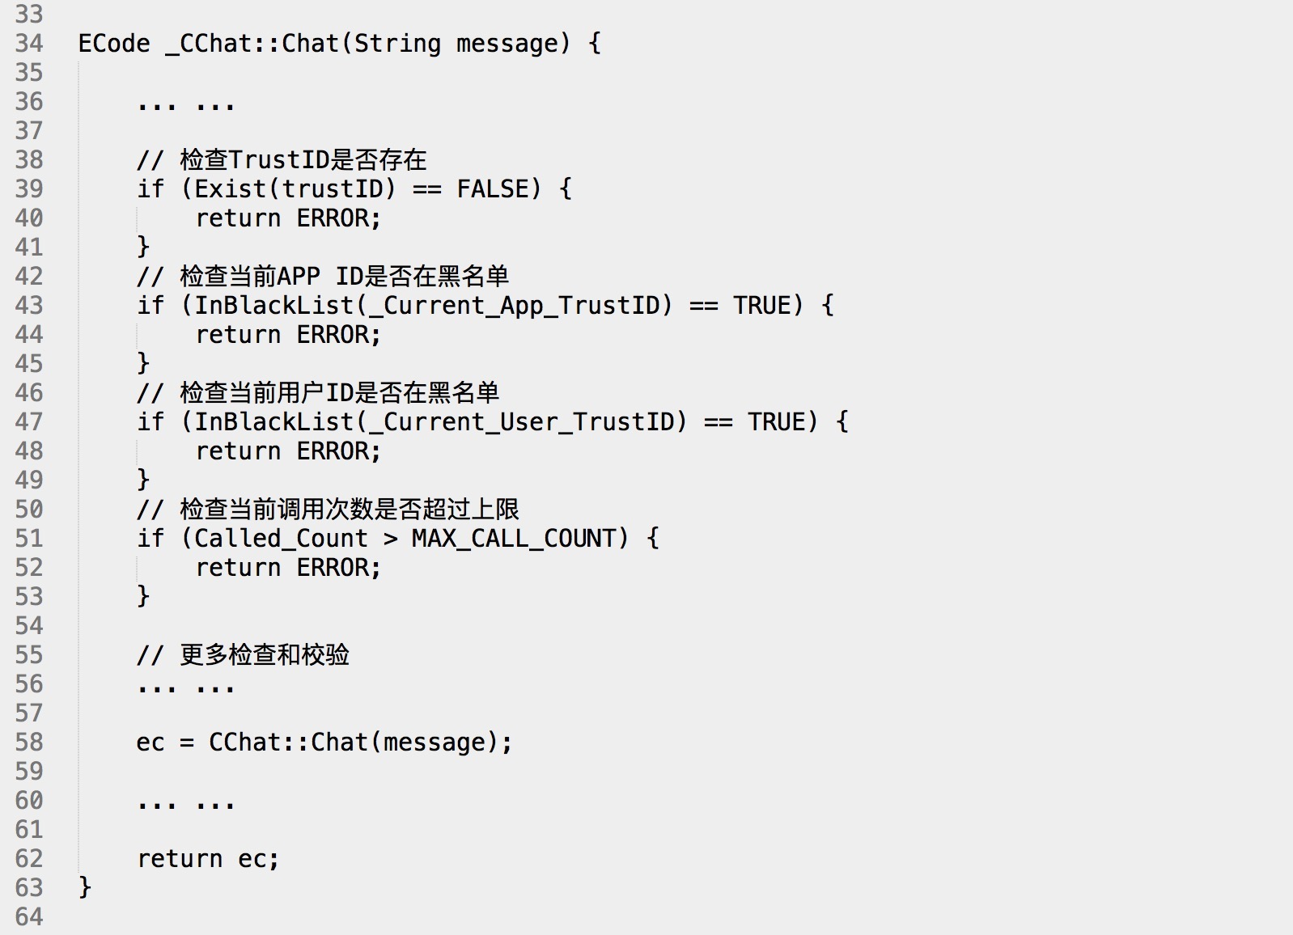

At this point, digital asset transactions may be performed. The following example verifies digital asset ownership:

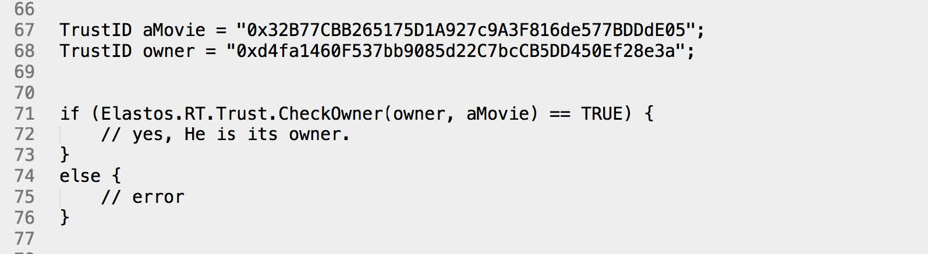

The following describes the transaction demonstration codes:

- Elastos Foundation

The Elastos Project has a long history which can be traced back to Chen Rong’s return to China in 2000 for starting his business. From that time on, Chen Rong has been committed to developing an OS which is secure, customary, and adaptable to the network era. In 2017, Chen Rong’s Elastos Project was transformed into a global software project which is open source and community-driven. The software which it develops, along with its documents, are released under “free and open source” software licenses.

The Elastos Project is operated and promoted through the Elastos Foundation for the purpose of fostering the Elastos Ecosystem. It actively embraces the open-source and digital-currency communities, and hopes that people may learn from each other for the sake of promoting the advancement and security of human civilization.

7.1 Global Community

Global Elastos fans, developers, document maintainers, community activity organizers, and ELA owners form the global Elastos community, which is the foundation of Elastos projects and the rich soil for Elastos ecosystem development. To build a vibrant, global Elastos community is a top priority.

Local Elastos communities will be formed by Elastos user groups around the world. Each user group will have an owner and operations team. Featured on the introduction home page of the Elastos official website are a world of involved Elastos community workers and volunteers.

User groups will be responsible for local Elastos community organization, maintenance, and development. Their main work will include:
- Promoting digital currencies and blockchains;
- Discussing Elastos technologies;
- Participating in Elastos project development;
- Writing and translating documents;
- Organizing local community monthly gathering;
- Organizing Elastos global activities.

7.2 Cultivation of Specialists

We are still witnessing the preliminary stages of the development of digital currencies, and of the blockchain. Since the industry is still undergoing rapid expansion, there has emerged a grave shortage of specialists. In response to this, in September of 2016, one of the founding members of Elastos, in conjunction with DACA, began a movement at Tsinghua iCenter called "All of Us Are Nakamoto Satoshi" for the purpose of providing specialist training aimed at the blockchain. Since its inception, the movement has been offering training to new specialists in large numbers, several of whom proceeded to join the Elastos team, eventually becoming the team’s main resource in dealing with blockchain matters. The Elastos Foundation will continue to support DACA's public access courses, which are held in conjunction with Tsinghua iCenter, in the hope that this movement may eventually become the blockchain sector’s own “Huangpu Academy,” in the process tirelessly producing more by more capable developers for the Chinese blockchain community.

7.3 Construction of an Ecosystem

Elastos, being the Smart Economy’s technological infrastructure, as it continues to provide support for distributed application development, will eventually give rise to an entire global ecosystem with the community of its specialists serving as the foundation. In order to construct this community more quickly, the Elastos Foundation will establish an Elastos Fund to be specifically used to invest in decentralized applications. The Elastos Ecosystem will allow the era of Bitcoin to be more safe, more intelligent, and more prosperous.

The goals of Elastos are grand and exciting. We hope you will join us in building an Internet infrastructure which will be innovative
and world-changing.

